**Steps to call Standard FM from Report**

1. Go to se38 and create a Report starting z/y.

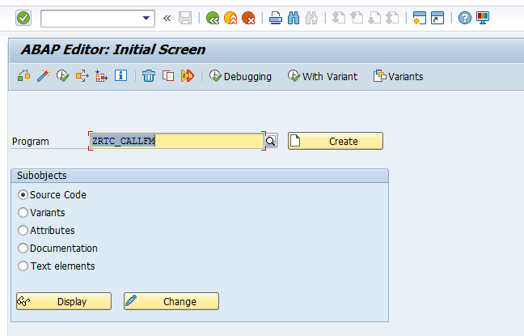

1. Add the below logic in the Report

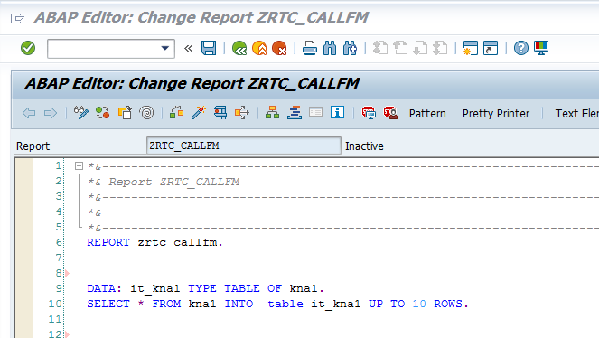

3 . Click on Pattern 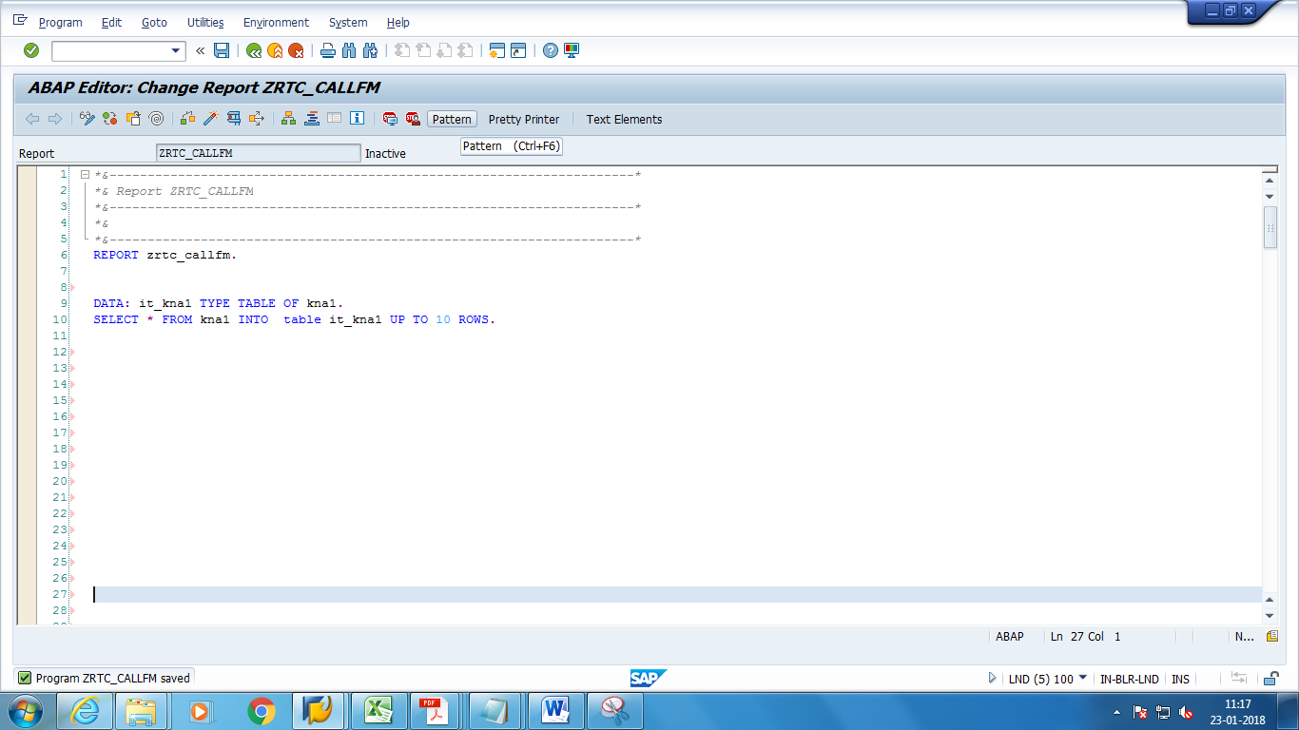

4. Select the radio button Call Function and give the FM name as **GUI_DOWNLOAD** and click on ok.

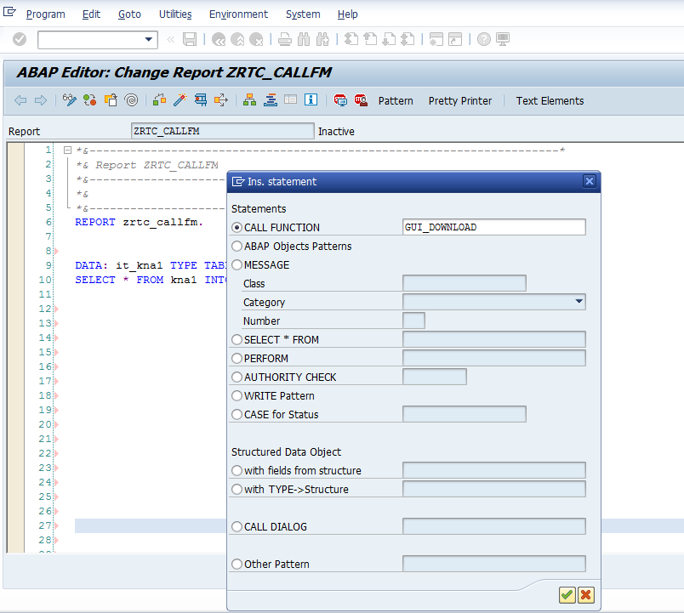

5. The following code gets added to your report.

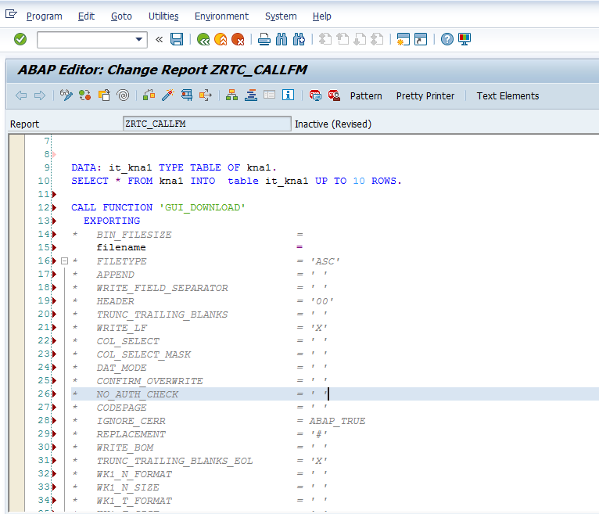

6. Modify the logic as below.

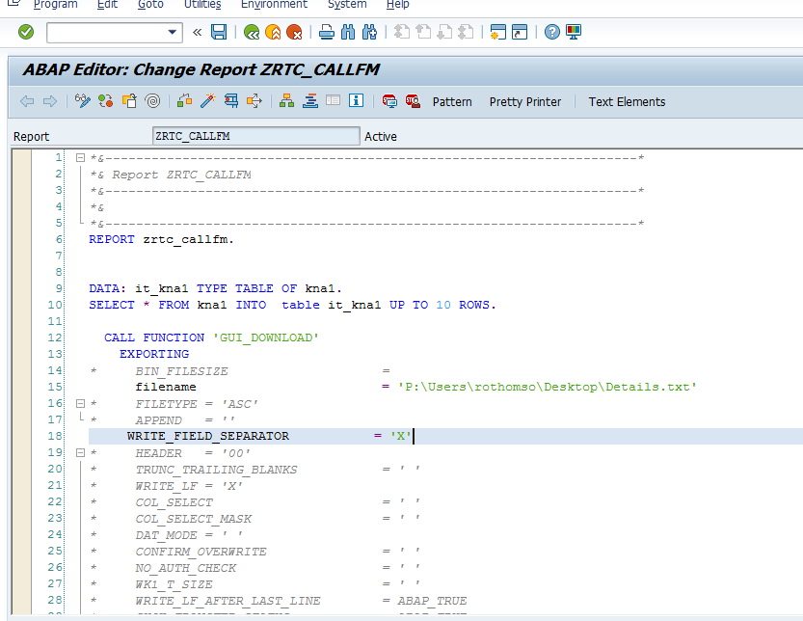

7. Save and activate the Report. Then execute the report and click on Allow in the pop up.

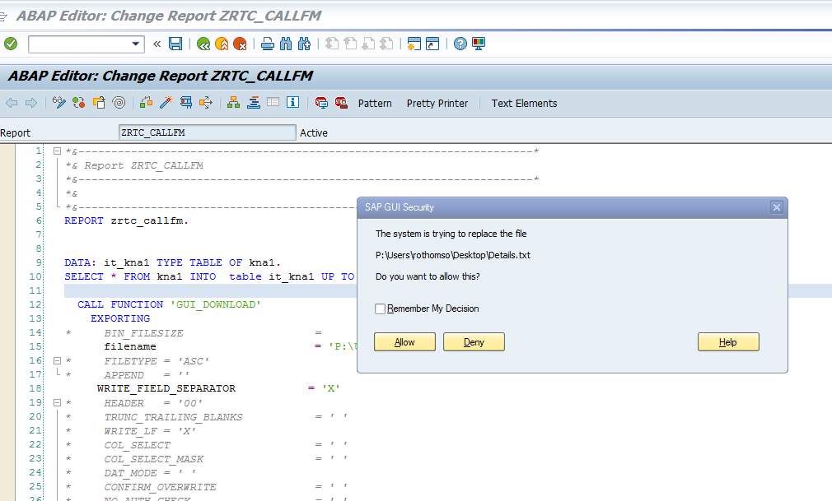

8. The expected output is as below:

Details.txt file is created in the path given in the Report.

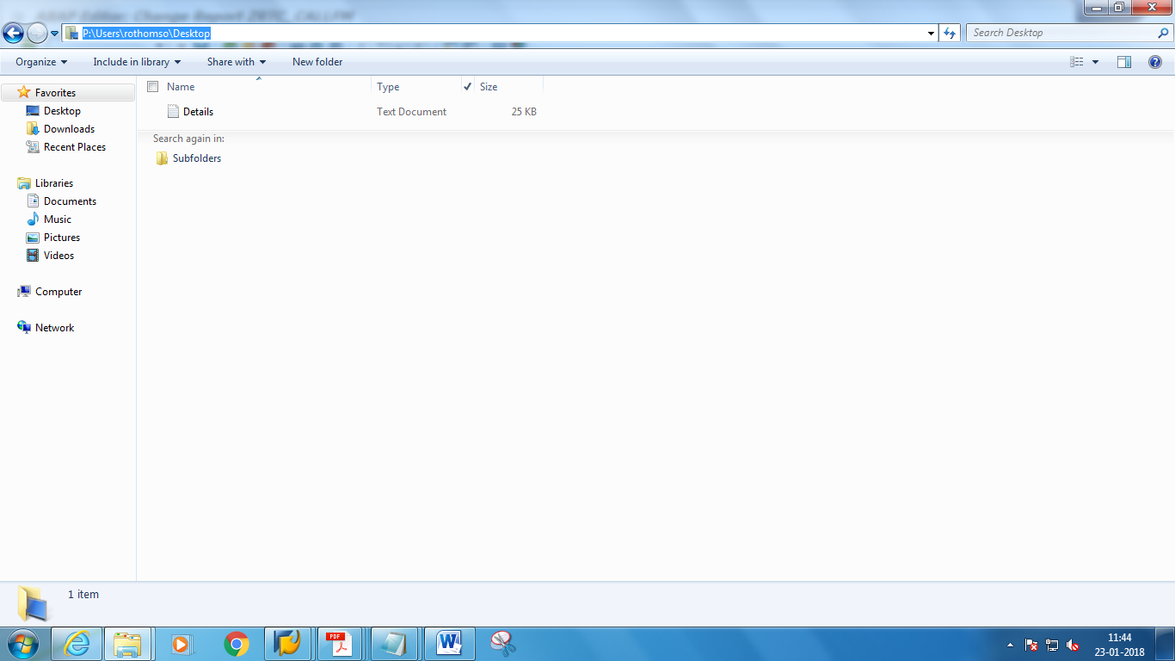

Content of the file

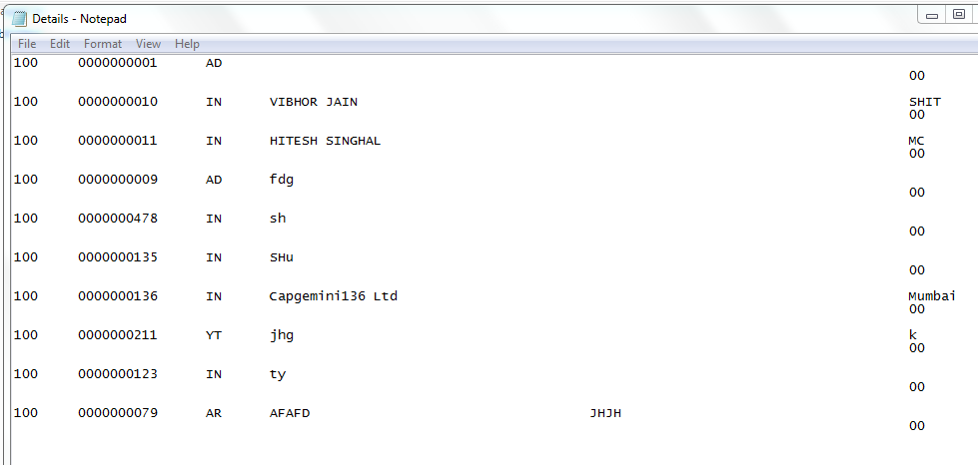

**Code:**

*&---------------------------------------------------------------------*  
*& Report ZRTC_CALLFM  
*&---------------------------------------------------------------------*  
*&  
*&---------------------------------------------------------------------*  
REPORT zrtc_callfm.  
  
  
DATA: it_kna1 TYPE TABLE OF kna1.  
SELECT * FROM kna1 INTO  table it_kna1 UP TO 10 ROWS.  
  
  CALL FUNCTION 'GUI_DOWNLOAD'  
    EXPORTING  
*\*     BIN_FILESIZE                    =*  
      filename                        = 'P:\Users\rothomso\Desktop\Details.txt'  
*\*     FILETYPE = 'ASC'*  
*\*     APPEND   = ''*  
     WRITE_FIELD_SEPARATOR           = 'X'  
*\*     HEADER   = '00'*  
*\*     TRUNC_TRAILING_BLANKS           = ' '*  
*\*     WRITE_LF = 'X'*  
*\*     COL_SELECT                      = ' '*  
*\*     COL_SELECT_MASK                 = ' '*  
*\*     DAT_MODE = ' '*  
*\*     CONFIRM_OVERWRITE               = ' '*  
*\*     NO_AUTH_CHECK                   = ' '*  
*\*     WK1_T_SIZE                      = ' '*  
*\*     WRITE_LF_AFTER_LAST_LINE        = ABAP_TRUE*  
*\*     SHOW_TRANSFER_STATUS            = ABAP_TRUE*  
*\*     VIRUS_SCAN_PROFILE              = '/SCET/GUI_DOWNLOAD'*  
*\* IMPORTING*  
*\*     FILELENGTH                      =*  
    TABLES  
      data_tab = it_kna1  
*\*     FIELDNAMES                      =*  
*\* EXCEPTIONS*  
*\*     FILE_WRITE_ERROR                = 1*  
*\*     NO_BATCH = 2*  
*\*     GUI_REFUSE_FILETRANSFER         = 3*  
*\*     INVALID_TYPE                    = 4*  
*\*     NO_AUTHORITY                    = 5*  
*\*     UNKNOWN_ERROR                   = 6*  
*\*     HEADER_NOT_ALLOWED              = 7*  
*\*     SEPARATOR_NOT_ALLOWED           = 8*  
*\*     FILESIZE_NOT_ALLOWED            = 9*  
*\*     HEADER_TOO_LONG                 = 10*  
*\*     DP_ERROR_CREATE                 = 11*  
*\*     DP_ERROR_SEND                   = 12*  
*\*     DP_ERROR_WRITE                  = 13*  
*\*     UNKNOWN_DP_ERROR                = 14*  
*\*     ACCESS_DENIED                   = 15*  
*\*     DP_OUT_OF_MEMORY                = 16*  
*\*     DISK_FULL                       = 17*  
*\*     DP_TIMEOUT                      = 18*  
*\*     FILE_NOT_FOUND                  = 19*  
*\*     DATAPROVIDER_EXCEPTION          = 20*  
*\*     CONTROL_FLUSH_ERROR             = 21*  
*\*     OTHERS   = 22*  
    .  
  IF sy-subrc <> 0.  
*\* Implement suitable error handling here*  
  ENDIF.